For Sale on behalf of a Client
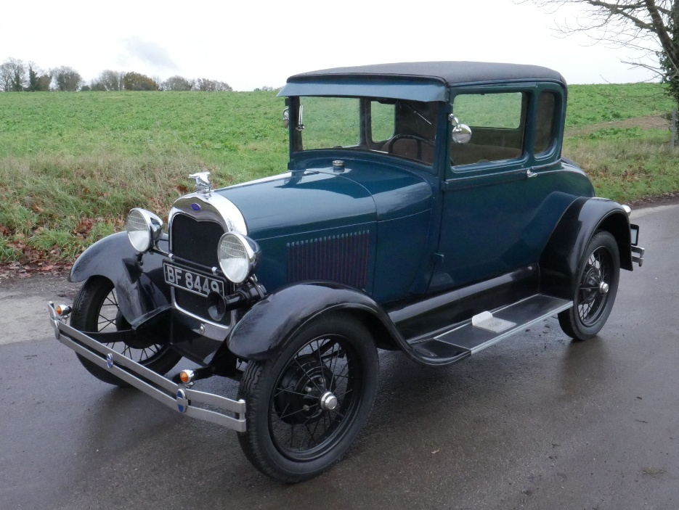
Make: Ford No. of Former Keepers: 3 (in UK)
Model: Model A Coupe M.O.T.: Exempt
Reg. No.: BF8449 Road Tax: Free
Chassis No: 1660879 Engine: 2041
Engine No: 1660879 Colour: Blue & Black
Mileage: not warranted Reg Doc: V5C
Year: 1929 Gearbox: 3 speed
Date of Reg: 17.10.2017 Fuel: Petrol

History: Lovely in blue and black, good body and paint with a few blemishes, excellent underside and chrome, very tidy engine bay, lovely refurbished cloth interior, rubber floor mat, starts easily, stops and drives very well. Was imported from the US in 2017 where it belonged to the ex-resident of the AACA (Antique Automobile Club of America), restored in USA including engine re-build, radiator, hoses and battery all look newish, good tyres, flashing indicators, recent ignition components and rebuilt petrol gauge. Seen service with a film hire company, comes with V5, Instruction Book, wiring diagram, vintage petrol can, brass fire extinguisher and a few tools. Great fun.
Viewing by appointment please. Tel: 07711 509600 or 07768 630969
Guide Price: £12,750
These particulars are believed to be correct but their accuracy is not guaranteed nor do they constitute an offer or a contract. Prospective purchasers should satisfy themselves as to the condition and suitability of the vehicle for their needs. No warranty, express or implied is given by Pioneer Automobiles or their Vendor Clients.

